ICT Solutions

Integrated One-Stop-Shop Model for Local Government
Case Management System of the I-OSSH Model

22/01/2016
This document has been prepared for the Decentralization and Local Development Programme - DLDP, in the framework of implementation of IOSSH model
Contents
Background: 5
1.1 IOSSh Model Components 6
2 Methodology to prepare the Administrative Procedures 8
2.1 Tools of the methodology 8
3 Developed methodology for IOSSh Model 11
3.1 Sample of LGUs which participated in the pilot project 11
3.2 Identification of the services 13
3.3 Consolidating the list of identified services 14
3.4 Preparing the extended service template 14
3.5 Mapping the Services with the functions 15
3.6 Consultation of the results with other partners 15
3.7 Reengineering of the service delivery process 16
3.8 Documenting the process workflow 16
3.9 Reengineering the process workflow 17
4 OSSh Software 19
4.1 Ability to accommodate changes 20
4.2 Sample Scenario: Add a new service in the IOSSh system 20
4.2.1 Sample of a new service creator through print screens from the application 21
4.2.2 Conclusion 28
4.3 Customized Data Entry Interface for each individual service 28
4.4 Data Privacy Control for scanned documents 29
4.5 Digital Signing Capability 29
4.6 Multichannel services 29
4.7 Able to integrate with Back Office Systems or other Gov Systems 30
4.8 Able to serve as a platform to provide services on behalf of other institutions 30
4.9 IOSSh system base technology 31
4.9.1 Base technology 33
5 Lessons Learned by IOSSh implementations 34
5.1.1 Conclusions 34
6. Capacity building 38

List of figures
_________________________________________________________________________________
Figure 1 - Conceptual Model of IOSSh 6
Figure 2 - IOSSh Model Components 7
Figure 3 - Sample of a Service Descriptor Template 9
Figure 4 - Phases of the pilot project 11
Figure 5 - Sample of four Municipalities part of the pilot project methodology 12
Figure 6 – Sample of four Communes/Administrative Units selected for the pilot project methodology 12
Figure 7 - Services Mapped to FPT Function Summary 15
Figure 8 - Basic Workflow Model for Prepared Service Workflows 17
Figure 9 - IOSSh System Features 19
Figure 10 - Role of the Process Designer 21
Figure 11 – Add a new service 22
Figure 12 – Configure the process 23
Figure 13 – Creating Data Entry Forms 24
Figure 14 – Design the service workflow 25
Figure 15 – Prepare the Printout Forms ( SmartDocs) 26
Figure 16 – Creating Data Entry Forms 27
Figure 17 – Cases Portal 28

Acronyms
_________________________________________________________________________________
GoA Government of Albania
MoIPA Minister of Innovation and Public Administration
MoSLI Minister of State for Local Issues
NAIS National Agency for Information Society
NRC National Registration Agency
STAR Support to Territorial and Administrative Reform
PLGP Planning and Local Governance Project
CoE Council of Europe
DLDP Decentralization and Local Development Programme
TAR Territorial Administrative Reform
LGU Local Government Unit
AU Administrative Unit
IOSSh Integrated One Stop Shop Model
FPT Financial Planning Tool

Background:
On 31st of July 2014, the Parliament of Albania has approved the law on TAR, which became effective after the local elections of June 21st, 2015. Albania is administratively organized in 61 new Municipalities and the former 308 communes are merged with these municipalities. In terms of public services that should be provided to citizens there are no major changes expected, as the merged LGUs have been transformed in Administrative Units and will continue to provide the same services and administratively perform as public service centers. The OSSH is considered as a supportive instrument for TAR implementation.

Providing administrative services to citizens in the administrative units creates a number of challenges and opportunities.

Challenges include the institutional model, authority delegation, effective organizational structure as well as tools and methodologies to formalize service delivery process.

Beyond the above challenges, a number of reforms are also taking place in Albania. These reforms include legal frame changes, which affect the functions of the new LGUs, as well as the procedures for providing services to the citizen.

For instance, the Social Aid programme is under reformation process, which at the time of writing this report has implemented a centralized computerized system piloted in Tirana, Elbasan and Durres. The piloted system and procedures are expected to be implemented in all Municipalities.

On the other side new opportunities arise from the wide territory coverage of the new Municipalities, facilitating a better planning and development of the territory as well as the design and implementation of new services. New services implemented in a wider territory would stimulate the territorial cohesion and social support and economic development.

- I-OSSH Model
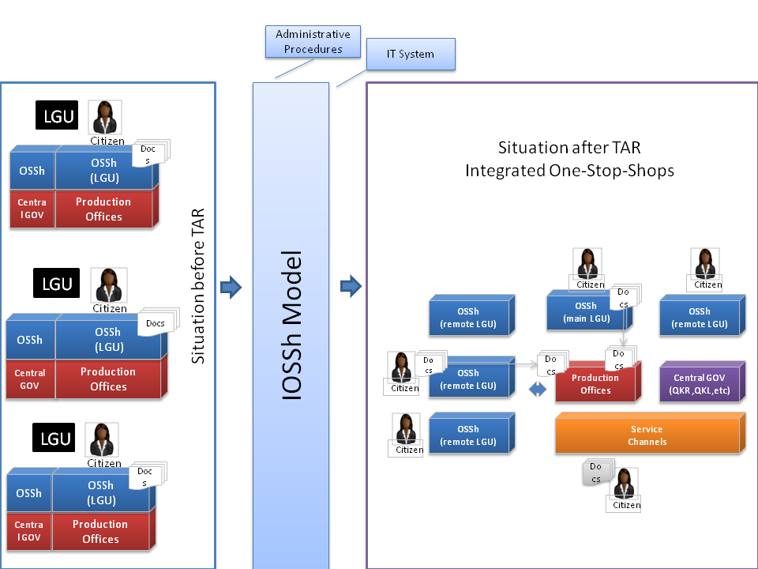
The IOSSh model for local government implements a service delivery model based on the One Stop Shop service delivery philosophy. In this model, Administrative Units serve as a service desk, responsible for accepting applications for administrative services and providing the final response to the citizen. The integration is created through a data network that connects the Administrative Units with the Municipality, while process automation software is used to provide the necessary functionalities to initiate service requests at desks (front office) of the administrative units and review them at the administration offices (back office) in the Municipality. The conceptual model of the IOSSh is illustrated below:

Figure 1 - Conceptual Model of IOSSh

IOSSh Model Components
The IOSSh model has three main components which provide the basis for the functionality of this model:
- Administrative Procedures
- Software System
- Training Curricula
Figure 2 - IOSSh Model Components
Administrative procedures are developed as a result of a methodology which consists on identification of the administrative services provided by LGU-s and reengineer the processes in order to develop a service model which is able to be implemented and executed through IOSSh model.
Software System enables the IOSSh model and has a number of features that guarantee the implementation of a cost effective, flexible and self-sustainable system.
Training Curricula is developed and is used to train and assess the knowledge of the administrative staff that will implement this model.

Methodology to prepare the Administrative Procedures
Administrative Procedures should be conceptualized as a legal act, which regulates the service delivery rules based on the “service description template” for each identified service. The methodology provides a roadmap for:
- Identifying the services provided at each Administrative Unit;
- Consolidating the list of identified services in a comprehensive list of services for all the Municipality;
- Preparing the service description template;
- Reengineering of the service delivery process in order to be able to run in the IOSSh model.

Tools of the methodology
The methodology uses the following tools:
- Service Definition
- Service Descriptor Template
- Extended service Template

Administrative Service Definition
At the time of development of this methodology, a legal definition of the administrative service was not available; herewith the methodology is based on the following definition:
“Administrative Service would be defined as a workflow regulated by legal acts, which is initiated by a citizen’s request and results in an answer for the citizen”.

For the purpose of this methodology the above definition is compatible also with the definition of the administrative services, set by the new draft law for Public Services in the Republic of Albania.
This definition made it possible to focus on a subset of public services, for example:
- “Garbage Collection” is a public service provided by the Municipality while it is not in the identified list of administrative services prepared in this study, because it doesn`t comply with the above definition. It is a service, but is not is not initiated by an individual citizen’s request and it is not provided through an written, official answer to the citizen;
- While the “request for a transport certificate license” complies the given definition because it is initiated by a citizen request and it is provided (concluded) through an official recognized document, the certificate.

Service Descriptor Template
A Service Descriptor Template is introduced for the identification process of the services or when a new service should be designed. The service descriptor template contains the basic information about the service, which is illustrated in the figure below:
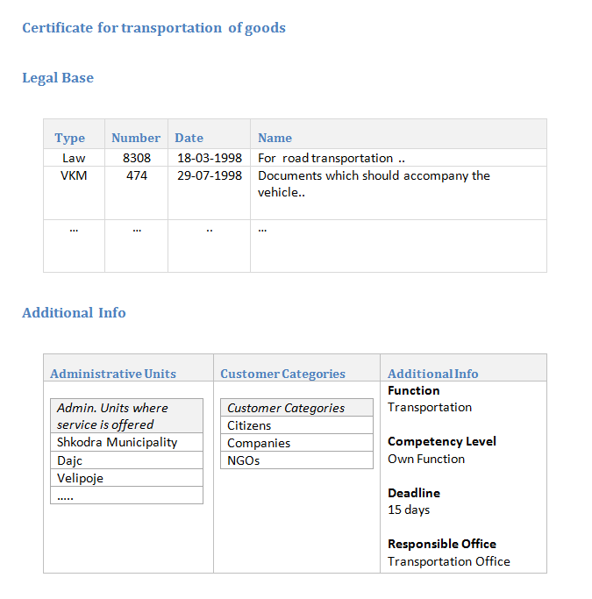
Figure 3 - Sample of a Service Descriptor Template
Service Descriptor template contains:
- Service Name
- Service Group
- A brief description
- Legal Basis
- Beneficiaries of this service categories (citizens, businesses, NGOs, others)

Extended Service Templates
An extended service template contains all the information necessary for the management of a service case.

The extended service template contains:
- Name of service: A service label.
- Group service: Function according to financial planning tool built by DLDP.
- Beneficiaries: Categories that will benefit from the service.
- Main Responsible Office: Office responsible for the service delivery, even though the service request should follow a reviewing process also by other offices.
- Deadline: Deadline in number of days – starting from the application day, when the applicant should receive the official response for his/her application.
- Legal basis: List of laws, bylaws and regulations ruling the delivery of the service.
- Documents for the application: List of documents to be filled and/or delivered by the applicant for the requested service. The extended service template defines also the format of supporting documents that will be delivered: original, notarized copy, copy, etc.
- Documents produced as a result of service request: List of documents produced by back-office (administration) as a result of the service review, including the intermediate documents such as; field observation form, rejection form, consent form, etc.
- Documents templates: are attached in extended service tab for every document produced during the application process: application form, rejection form for license, authorization form, etc.
- Workflow: Workflow is described as a list of steps; wherein each step is an action based workflow. Workflow is divided into three phases clearly separated one from another:

Developed methodology for IOSSh Model
The above described methodology is piloted in a sample of eight (old) LGUs. The above methodology is implemented for the drafting of the administrative procedures for the Municipality of Lezha (before enforcement of TAR/local elections). The implementation process followed a phased approach, as it is demonstrated in the figure below:

Figure 4 - Phases of the pilot project

Sample of LGUs which participated in the pilot project
The study is conducted in eight LGUs before local elections and implementation of TAR. The selected LGUs were compounded by four twins of Municipality - Commune, which have corresponded to four new Municipalities and Administrative Units after TAR implementations.
The figure below lists the four old municipalities, which have been part of the study and their typology: 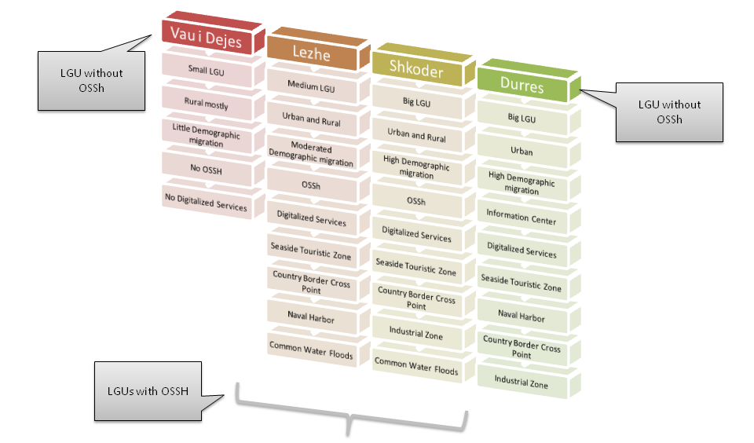
Figure 5 - Sample of four Municipalities part of the pilot project methodology
While the figure below lists the typology of the four selected Communes:
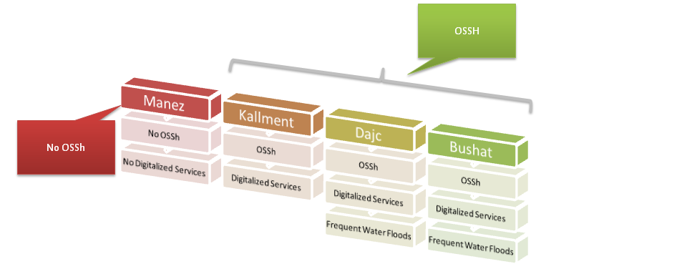
Figure 6 – Sample of four Communes/Administrative Units selected for the pilot project methodology

With the new territorial administrative organization:
- Manez is an Administrative Unit of the Municipality of Durres
- Kallmet is an Administrative Unit of the Municipality of Lezhe
- Dajc, Bregu i Bunes is an Administrative Unit of the Municipality of Shkoder
- Bushat is an Administrative Unit of the Municipality of Vau i Dejes
The illustrative figures above present a number of characteristics of the selected LGUs in a compacted manner. The selection criteria of these LGUs is focused firstly on the programme area of DLDP, which covers Northern Albania, DLDP previous contribution in developing an OSSh model in seven old LGUs and the typology of the selected LGUs, which is essential, in order to validate the unified list of services in other LGUs.
For example:
- LGUs which had in administration seaside touristic zones might provide services which are not provided by other LGUs, or
- LGUs which are more often confronted with natural disasters such as water floods might be more likely to provide services which provide assistance in cases of natural disasters than LGUs which are less affected by these situations.

Important note:
The methodology for the identification of services delivered by LGU-s, was a crucial part of piloted project for the development of IOSSh model. Still, the list of services identified during the study, should be considered as a reference list, as the implementation of the IOSSh model in all levels of a new municipality (including all administrative units or regions) will potentially identify additional services due to different typologies of Municipalities, new functions and local autonomy principle.

Identification of the services
The following sources have been utilized as a starting point to consolidate the list of services already delivered by LGUs:
- Services already identified using this methodology by the study conducted during the piloting phase for the building of I-OSSH model;
- Fiscal package: Some administrative services are subject tariff fees. This tariff fees are approved as part of the yearly fiscal package.
- Protocol Book: based on the law ‘On Archives”, LGUs register the citizens request in the protocol book of the institution.
- Interviews: Interviews with employees of municipality and administrative units.
Once a service is identified the Service Descriptor Template is prepared.

Consolidating the list of identified services

Consolidation of the identified list of services in an inclusive list for all LGUs could be done through the consultation of the service descriptor templates with the staff of the municipality and through the study of the identified legal base.

The first phase of consolidation for the list of services was a task based on services with similar names and functions and the same Service Descriptor Templates. While there have been services which had similarities but it was not possible to consider as duplicates, since the information on the Service Descriptor Templates was slightly different:

“as an example could serve the case of the same identified service with different legal basis that regulates the service delivery. This might be a result of the lack of updated information on legislative changes”.

Through several workshops with the local experts, local administration employes and center of competence supported by DLDP, the list of services have been further consolidated to a final list of 67 services. For this final consolidation additional information of the identified service are used:
- Application Form
- List of Documents required
- Function of the resulting document

Preparing the extended service template
Preparing the extended service description template it is a task which required filling in the necessary information in an empty template. Part of the information is already available in the service descriptor template, while some information could be found in the same sources used to identify the list of services.

Mapping the Services with the functions
In order to categorize the services according to the LGU functions, the FPT categories are used. FPT is a budgeting mechanism developed by dldp to assist Municipalities in budget preparation and financial planning in general, based on LGUs direct, shared or delegated functions.
The figure below shows a summary of the number of services as per FPT function:

Figure 7 - Services Mapped to FPT Function Summary

Consultation of the results with other partners
The results of the study have been progressively consulted and validated in different platforms with interested GoA representatives (MoIPA, MoSLI, NAIS, NRC) and partner programs (STAR, PLGP, CoE, etc) involved in the process. The above-mentioned actors have carefully followed project implementation and provided constructive comments and recommendations. The methodology and the first identified list of 67 unified services have been shared with all partners and it has been a reference in other similar projects developed, as well as for the Decentralization Strategy approved by GoA. The piloted system in Lezha and Kallmet has been also promoted by MoSLI and MoIPA during the ‘Smart City” day, of innovation Week, organized by MoIPA in May 2015.

Reengineering of the service delivery process
In order to provide the services through IOSSh system is mandatory to make a clear division between the three phases of the service delivery process:
- Accepting the application
- Reviewing of the application
- Providing service official response or results to the applicant (license, permit, authorization, certificate, certification, etc.)
In general accepting the application would be allowed in each service desk in all administrative units of the municipality, while providing the answer/service to the citizen requires a case by case analysis.

At first, the legal base should be reviewed and confirmed, in order to certify the level of institution authority that shall deliver the final document for the requested service (signed and sealed) at the administrative unit, as well as defining the cases when the documents should be certified (signed and sealed) specifically by the Mayor.
If it is stipulated by legal frame, it depends to Municipality decision-making level the number and type of services that might be delegated to the administrative units’ authority, in order to be certified and delivered.

A considerable number of application forms and final documents templates (such as transportation licenses) are defined by legal acts that regulate the service delivery standard. When the forms are not defined by legal acts, adoptive forms with all elements of identification symbols and workflow procedures by municipality should be designed.

Documenting the process workflow
The process of identifying the service workflow continued on four old LGUs or two twining samples that will function as Municipality-Administrative Unit after TAR implementation:
- Lezhe - Kallmet
- Shkoder – Dajc, Bregu i Bunes
The third tool of the methodology “Extended Service Template” is used for this phase.
The documentation of the service workflow is done through interviews with employees from the existing OSSh-s desks (front offices) of main administration in municipalities (back-office). The Extended Service Template was filled in for all identified services during this documentation process. The sections of Legal framework, Application forms, List of Documents have been easy to fill in, because of the information access; while the process workflow was a challenging process to be documented. As an administrative practice, the process workflow in general was not formalized in a document; herewith there might be different paths for practices of the same process.

Reengineering the process workflow
The documented Extended Service Templates in each LGU are analyzed and consolidated in one Template per service, which contains all the information from the Extended Service Templates for the same service filled in all four LGUs.
The workflow section of the extended service template is re-written as a series of steps followed a staged approach, which divided clearly three phases in the process (application, reviewing and response).
The figure below, illustrates the base workflow model for all service workflows prepared:
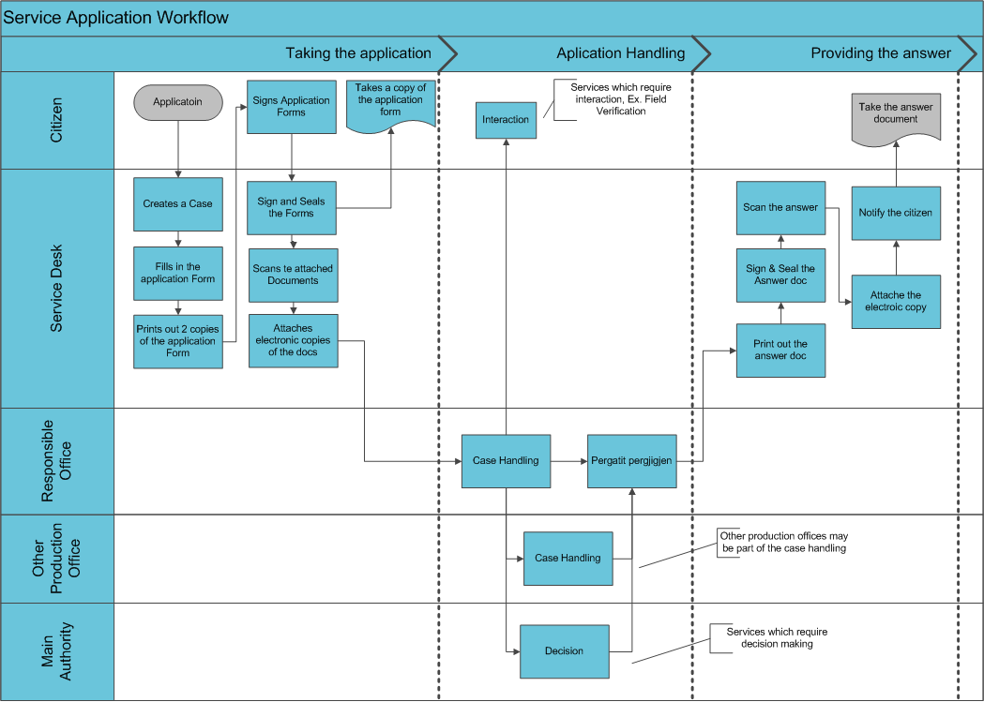
Figure 8 - Basic Workflow Model for Prepared Service Workflows

Service Workflow Approval
Service workflows are built based on the above workflow model; although the legal base is studied for each service, to make sure that the workflow meets the legal constraints.

Important Note:
The prepared workflows provide defined roles for local administration; hence fore, it should be also approved by municipality, in order to guarantee the model functionality. Within the legal constraints the municipality has the authority to decide the workflow to be followed in order to deliver a service. This is an issue which should be treated in a case by case manner with each municipality. It is not possible to prepare a common model of service workflow applicable for all municipalities, due to different types, conditions, infrastructure, human or financial resources and decision-making power of each municipality. Furthermore the workflow might require to be changed during the same administration and with a higher probability when the administration changes. The reengineering phase of this methodology is herewith applied repeatedly, every time when changes are required by the municipality or because of legislation changes. This is an important aspect of implementation process, especially related to the fact that Albania is under consideration of several national reforms processes.

OSSh Software
This report introduced a methodology which guides the municipalities toward the implementation of the IOSSh model for providing administrative services to citizens. This section will present an exercise of applying this methodology to prepare the administrative procedures for the for the Municipality of Lezha.
The second enabler component of the IOSSh model is the software. The software used for the implementation of IOSSh model provides a straight forward method of entering the prepared extended service templates into it, and start running cases for that service requests. The software has a key feature which guaranties a long life of the IOSSh system, which is “the capability to accommodate changes”, since this is the biggest challenge to be faced by IOSSh model at municipalities.
The IOSSh model is implemented in process automation software called Smart Processes. The software is web based and provides features which enable the IOSSh to be:
- Flexible to changes
- Customized Data Entry Interface for each individual service ( Case Management instead of file tracing)
- Data Privacy Control for Scanned Documents
- Digital Signing Capability
- Able to provide multi-channel services
- Able to integrate with Back Office Systems or other Gov Systems
- Able to serve as a platform to provide services on behalf of other institutions

Figure 9 - IOSSh System Features

Ability to accommodate changes
The technical solution implements a centralized system at the main LGU and IOSSh units established at administrative units, connected to the central system.
Processes are designed with a friendly use concept, web based drag and drop interface in all the components of a process:
- Data entry forms
- Workflow ( cases statuses, steps and rules)
- User Roles
- Generated Printable Forms
- Attached Scanned Documents
- Communication with other systems
- Communication with other channels ( email or SMS notification on events)

After being created, the processes are sent for execution in the “Cases Portal”, which is the main workspace of IOSSh users. A similar environment with limited functionality is also provided in the web portal to the citizens. This method provides a level of functionality which guaranties that the IOSSh system is able to adapt to legal changes which might affect the administrative services. This is an important aspect for the sustainability of the IOSSh in the conditions when several reforms are on the process in Albania. The following scenario aims to illustrate the ability of the IOSSh system to accommodate changes.

Sample Scenario: Add a new service in the IOSSh system
This scenario explains how a new service is added into the IOSSh. The chosen service is “Request for Financial Assistance in case of Natural Disaster”. This service is added to the IOSSh system in Shkodra and Lezha, the first week of January, 2016 due to the fact that water floods have caused damages to the citizens in these municipalities. The new service is added by the local IT Administrator, which in this case have executed the “Process Designer” role, indicated in the figure below:
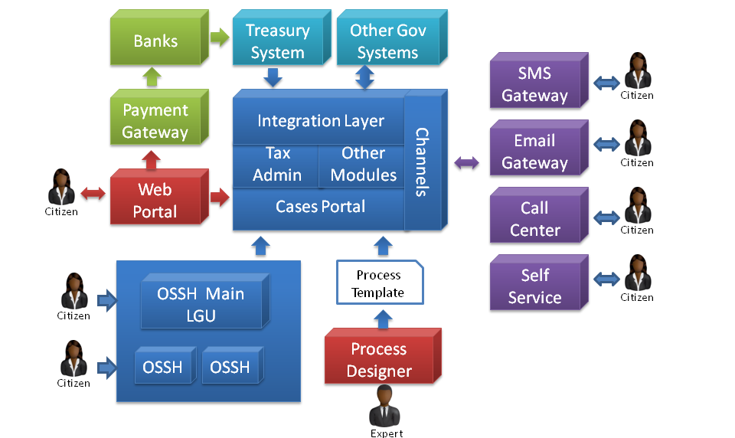
Figure 10 - Role of the Process Designer
The “Process Designer”, should not be necessary an IT professional; it could also be an administrative service domain expert, which has the necessary training to use Smart Processes. This is possible because creating new processes with the most common features is an easy task done with a drag and drop interface. Configuring advanced features such as child processes, web service integration or notification events is also done through a drag and drop interface, however IT knowledge about web services and events is required.

Sample of a new service creator through print screens from the application
The print screens that are edited below demonstrate some of the steps from the application of a new service creator:
Step 1 - Creating the Process
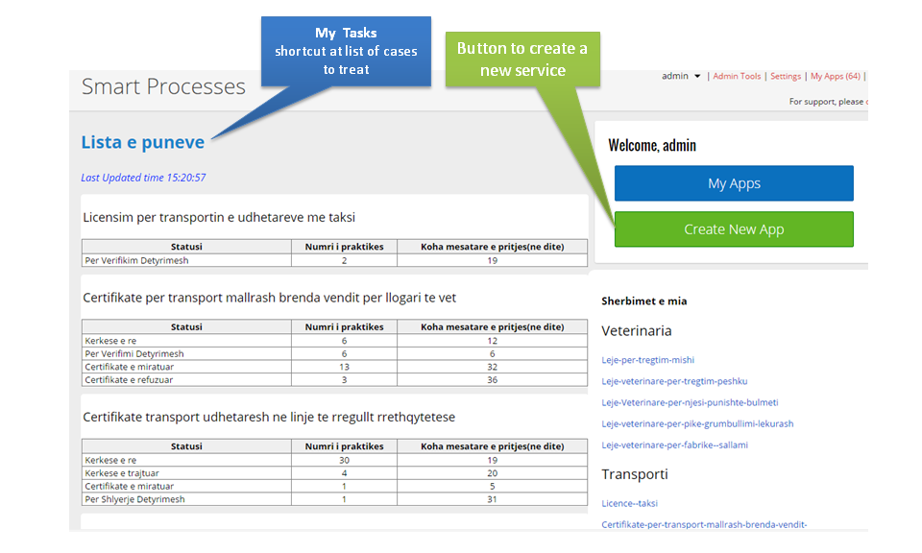
Figure 11 – Add a new service
The figure New App creates a new service. Afterwards the process configuration is opened.

Step 2 – Configure general parameters of the process
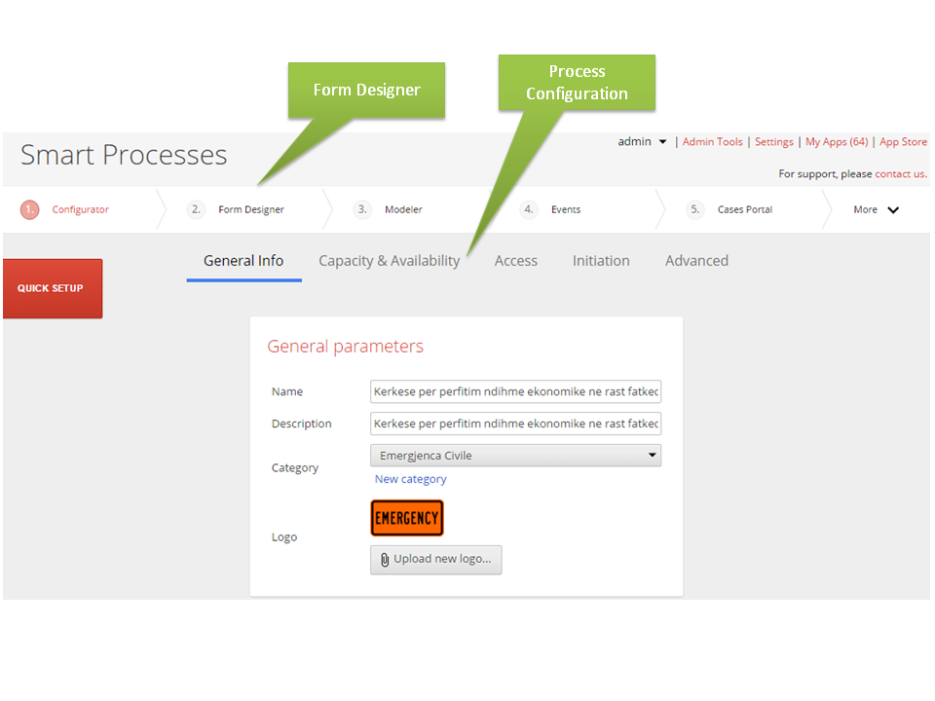
Figure 12 – Configure the process
Process Designer then configures the process in terms of: General parameters ( process name, a short description, a process category, and a process icon) , Process Capacity ( Maximum Number of Cases per Process, Maximum Number of Cases per Case Initiator ,Maximum Number of open Cases per Case Initiator) , Process Availability (Time when it is possible to start creating cases in this process , Deadline up to which is possible to create new cases in this process, Deadline up to which is possible to modify cases in this process). Afterward the Data entry form(s) have to be designed through the Form Designer.

Step 3 - Creating the data entry form(s)
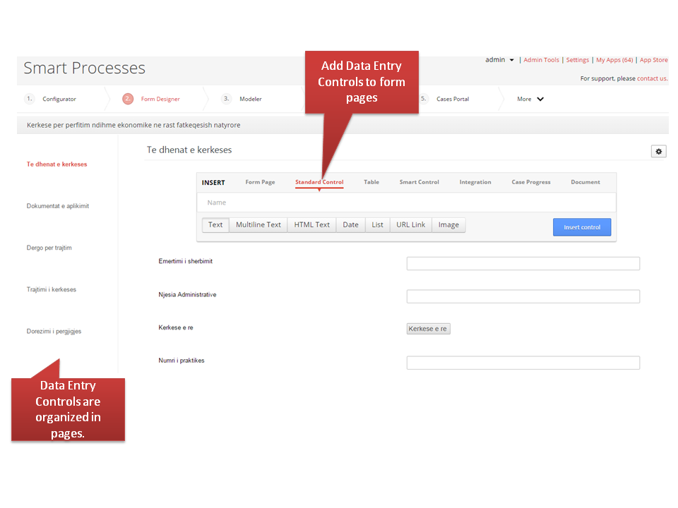
Figure 13 – Creating Data Entry Forms
Each process has a data-entry form. Data-entry controls are organized into pages. Pages are a container object which is refereed in the access rights configuration, thus providing different views of the data entry form for different user roles depending on the status of the individual case of the processes. All input controls are added through form designer including attachments and printed out forms (called SmartDocs in Smart Processes).

Step 4 – Design the service workflow
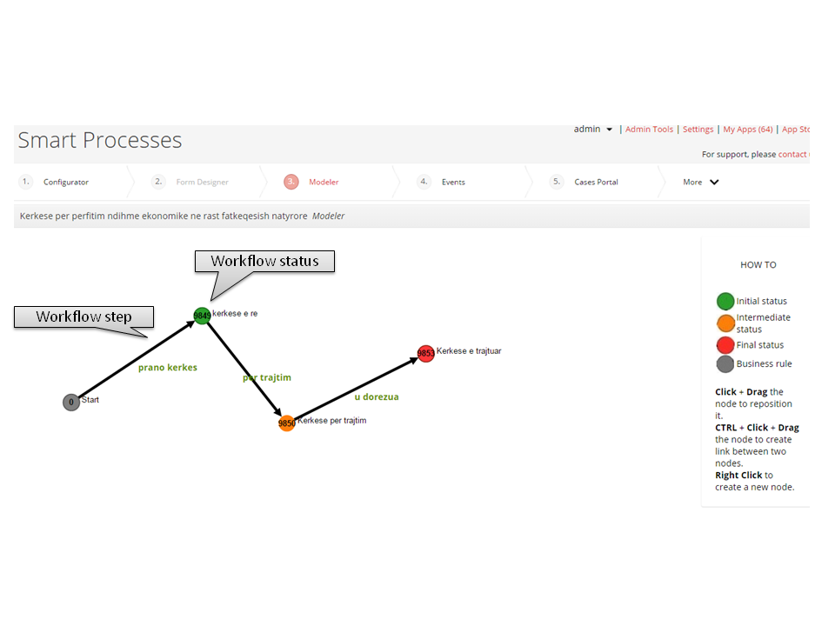
Figure 14 – Design the service workflow
Each process has a data-entry form. Data-entry controls are organized into pages. Pages are a container object which is referenced in the access rights configuration, thus providing different views of the data entry form for different user roles depending on the status of the individual case of the processes. All input controls are added through form designer including attachments and printed out forms (called SmartDocs in Smart Processes).

Step 5 – Prepare the Printout Forms (SmartDocs)
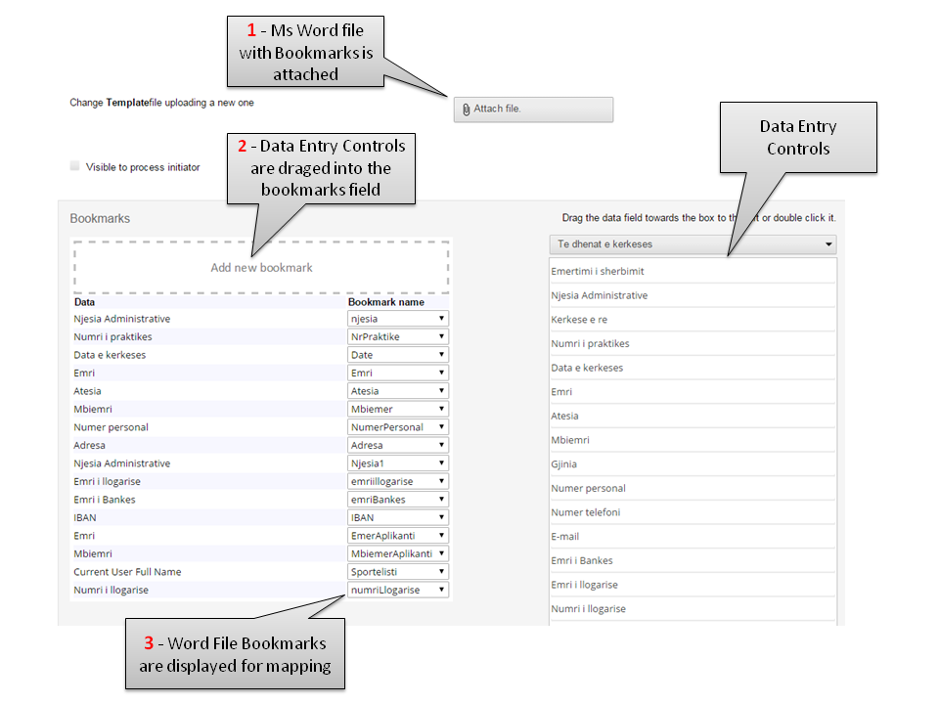
Figure 15 – Prepare the Printout Forms ( SmartDocs)
The process designer prepares a Ms. Word document with content and named bookmarks. The document is attached in the SmartDocs configurator. Finally he drags the data-entry controls into the bookmark field and map them with the desired named bookmark added in the Ms. Word document.

Step 6 – Configure User Roles and Access Rights(s)
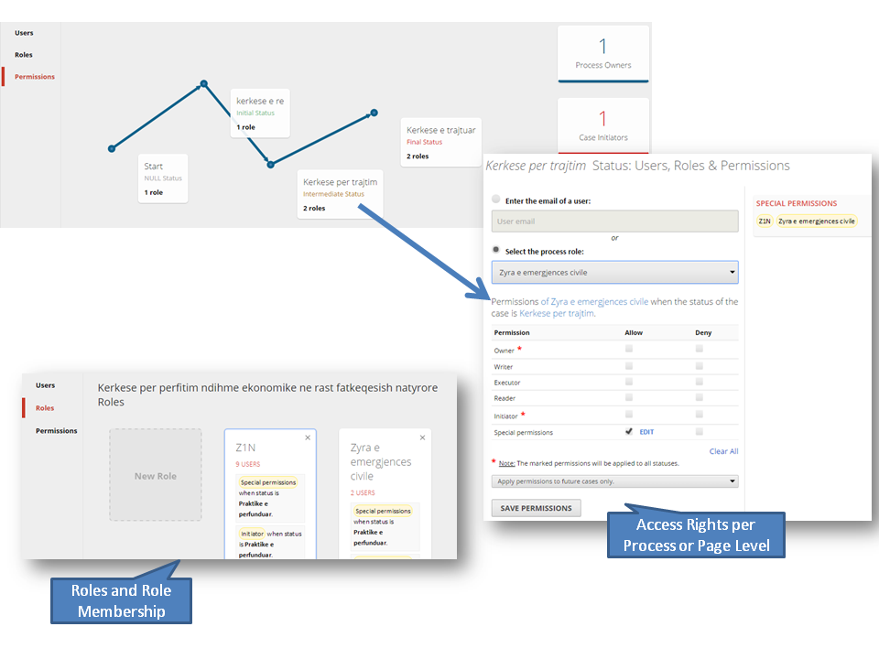
Figure 16 – Creating Data Entry Forms
Create Roles and manage user role membership. Define the access rights for the cases for each of the process statuses. Access level can be defined for the entire form or to be detailed at page level access.

Cases Portal - Create and manage cases
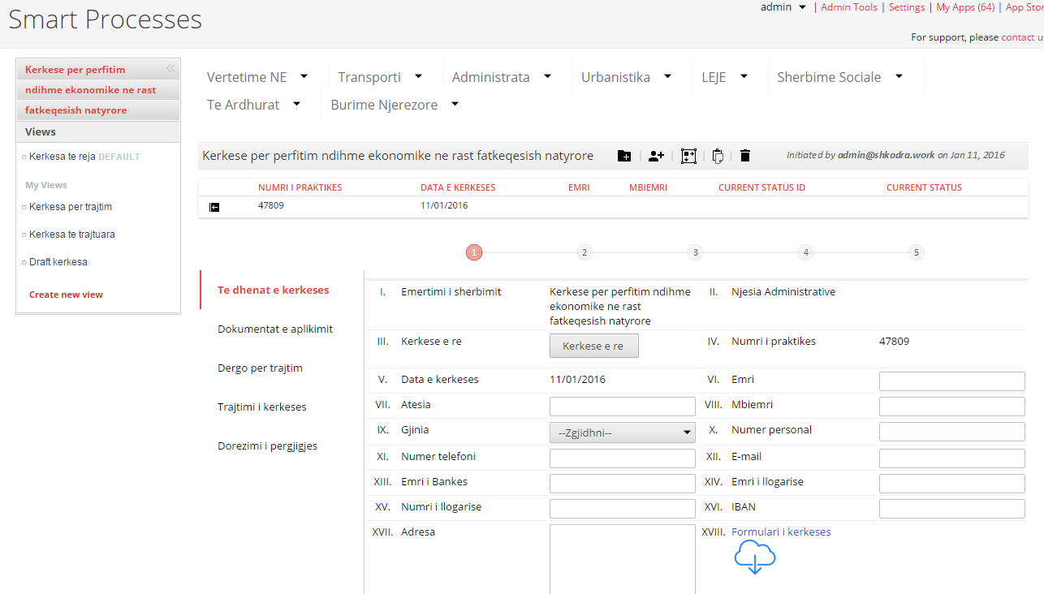
Figure 17 – Cases Portal
Web portal is used to create and manage cases in this process.

Conclusion
As demonstrated in this illustrated scenario, Extended Service Template is prepared for a service; the local staff of municipality is capable to create a new service in the IOSSh system through the IT Manager or another trained employee. This makes the IOSSh system flexible to adapt to changes.

Customized Data Entry Interface for each individual service
Case Management instead of file tracing
As demonstrated in the sample scenario of creating a new service, each component of a service is created through a drag and drop interface. This allows the creation of customized data-entry forms for each service, depending on the data that the service requires. This approach provides several advantages compared to an approach where only data that has to do with the request handling is captured, and get information required in the attached documents:

- Data capture at the application eases the application/request review through filtering, dynamic routing of cases using data based rules etc.;
- A database with brows able data is created as a normal working procedure;
- A detailed analysis of the service delivery performance could be done based on the data generated by created cases;
- Back Office enters data for the application/request review in the case practice created in the application, herewith providing a transparent and easily auditable case management practice.
- Integration of the cases with other systems such as back office software or other Gov Systems could be implemented to read and write data from the cases.
- Integration with other systems allows operating as an interface for services provided by other institutions.

Data Privacy Control for scanned documents
There are regulatory guidelines that obligate LGUs for data privacy protection of the scanned documents, provided but the citizen at the application for a service. The web based scanning tool part of the Case Management triggers the scanning device directly from the browser, thus scans the documents without leaving a copy of the scanned document in the local desk computer.

Digital Signing Capability
Smart Processes has implemented the secure authentication and digital signing services provided by Aleat. Given that, a commercial agreement between the municipality and the service provider is established, it would be easy to activate the authentication and signing of digital signing of the documents.

Multichannel services
Beyond the service desks, IOSSh system has:
- A web portal which would allow the citizen to get information about the status of his service case/application. In addition, the web portal provides the option of application online for an administrative services.
- Integration with SMS Gateway to trigger messages based on Case/Application Events.
- Self-service kiosks could also be connected to IOSSh system to provide status update of the cases/application.

Able to integrate with Back Office Systems or other Gov Systems
The software, on which the IOSSh system is based, allows through the feature “Web Service Event” the configuring of an event which calls a web service through an easy to use “drag and drop” interface.
- Process Designer enters the web service address (url).
- Smart Processes will query the metadata of the web service and list its published methods.
- Process Designer chooses the desired method of the web service to be called.
- Smart Processes will query the metadata of the web service and list the arguments of the chosen method.
- Process Designer maps the data-entry fields of the process with the arguments of the web method.

After this configuration steps when the triggering case event will fire the web service method will be called and the data from the case will be synchronized with the mapped arguments of the web service method.
For example, when a tax-id data-entry field is updated a web method is called which takes the tax-id values as an input argument and provides the name of the company as an output argument. The output argument will be written to the field value of the data-entry form to which it is mapped in the configuration.
This feature enables IOSSh system to integrate very easily with other systems through standard web service interface. This integration can be configured by the IT Administrator of the municipality and does not require any additional software programming.

Able to serve as a platform to provide services on behalf of other institutions
The web service interface allows the IOSSh system to operate as an interface for other systems. The above feature enables scenarios where citizens make request for services offered by other institutions through the IOSSh system. IOSSh system will store the request, send it to the back end system of the institution through web service, query the status of the case from the back end system and provide the answer to the citizen. This feature allows IOSSh to serve as a platform to provide services on behalf of other institutions.

IOSSh system base technology
IOSSh system is based on Smart Processes copyrighted software of ICT Solutions.
Smart Processes is available in three different editions.

- Smart Process Enterprise Edition
- Smart Process Standard Edition
- Smart Process Cloud Edition

Smart Process Standard Edition is offered as a proprietary license to use Smart Processes with all the necessary functionalities to model processes and process cases.
Smart Process Enterprise Edition is also offered as a proprietary license to use Smart Processes with all the necessary functionalities to model processes and process cases. In addition to the functionalities of the Standard Edition, the Smart Process Enterprise Edition includes Child Processes.

Smart Process Cloud Edition is offered as a yearly subscription license to use Smart Processes.
Smart Processes is activated instantly without any additional investment in hardware and additional software licenses, complex installation procedures and backup procedures.

Smart Process Cloud Edition licensing model is based on the number of processes rather than on software license. This licensing model based on the principle of “Pay only for what you need and for how long you need” makes Smart Processes accessible to organizations of different sizes, independently of their budget limitations. Smart Process Cloud Edition customers are paying a yearly fee only for the process or processes that they have. They can archive and download their processes data if they decide to not use anymore Smart Processes.

A comparison table below describes the differences between the product editions
Product Editions / Features | Standard Edition | Enterprise Edition | Cloud Edition
Licensing Model | Proprietary License | Proprietary License | Per Process Yearly Subscription License
Business Rule Configurator
Business Rule Modeler
Form Designer
Integration Controls
Smart Documents
Email Templates
Cases Portal
SQL Calculated Fields
Child Processes
Hosting
Daily Backup
Users | Unlimited | Unlimited | Unlimited

For IOSSh system Smart Process Enterprise Edition is used accompanied with a Smart Processes VPN Site License for the Administrative Units.

Base technology
Smart Processes are developed on top of Microsoft dotNet framework and use Microsoft SQL Server as a database system. Smart Processes is fully operational when running on top of SQL Server Express Edition. The limit of 10GB per database imposed by SQL Server Express Edition is far beyond the expected database size increase of IOSSh database. The estimated yearly database size increase is less than 500 MB per year, while the current database size of both IOSSh systems implemented is less than 600 MB. The projected database size after 10 years would be less than 6GB. This simple calculation demonstrates that a fee based database license is not required for IOSSh system.
Due to the fact that is based on widely known programming languages and environments in Albania (Microsoft dotNET programming languages and SQL Server) IOSSh system gives the necessary level of independence to the Municipality to develop other functionalities connected to the IOSSh system using its internal resources or external contracts.

Lessons Learned by IOSSh implementations
The IOSSh system is under implementation phase in the Municipalities of Shkodra and Lezha, including Administrative Units of Dajc, Bregu i Bunes, velipoje, Kallmet and Shengjin. The implementation of IOSSh system in Lezha started with the piloting of the system in February 2015, while at the Municipality of Shkodra the implementation started in November 2015. Until December 2015, there are 86 digitalized services configured and active in both municipalities.
The implementation projects in both municipalities aims to consolidate the digitalized services as well as to enter new services which might emerge due new functions delegated to the Municipalities in 2016.

Conclusions
The so far implementation of the IOSSh in the municipalities of Shkodra and Lezha generated interesting conclusions which would help other LGUs to plan and execute the projects for IOSSh implementation. The tables below provide an overview of the configured services in the two municipalities.
Table 1 - Overview of Services Configured in Lezha Municipality
Services Configured
Number of Services | 78
Average Forms per Service | 3.62
Average Workflow Steps per Services | 5.55

Table 2 - Overview of Services Configured in Shkodra Municipality
Services Configured
Number of Services | 67
Average Forms per Service | 6.66
Average Workflow Steps per Services | 6.54

The tables above are an illustration of the fact that it is not possible to have a unified IOSSh system for all municipalities:
- While legal framework assigns functions to the Municipalities, the way how those functions are translated into services is subject to the decision of the municipality
- Different Organizational Structures and different management decisions will create different workflows which would provide different printed forms to accompany the workflow of a service case.
The table below provides a statistic on the number of cases created in the IOSSh system in Lezha during 2015.

The number of the cases created in the IOSSh system in the municipality of Lezha is bigger in the first months of the implementation due to a high focus of the management of the Municipality on the implementation of the IOSSh. All Social Economic Support cases are entered in the system as well as all cases of the disability payments. This is the reason why there is a high number of cases for 16 services requested in February.
While the number of cases decreases the number of requested services increases, in the following months. This is due to the fact the existing practice cases of the social economic support and disability payments are used to provide additional services to the citizens.
For example a certificate for taking economic financial aid is printed directly from the existing practice case of the citizen.
There number of the cases decreases considerably in the months of July, August and September. This period coincided with local elections period and the management changes of the Municipality.
New leading management made considerable changes in the workflow of delivering services, especially related to documents templates printed out by IOSSh system, adding of new services and deactivation of existing ones.
In September started the process of applying the above changes in the IOSSh system. In the following months October, November and December the number of cases started to increase since the changes are implemented in the IOSSh.
This example stresses an important feature of the IOSSh system. It would be able to accommodate changes. The IOSSh system must allow to reconfigure the workflow, the forms printed user roles in a fast way without additional software programming. The IOSSh system must allow creating new services without additional software programming. This IOSSh system feature must be available in a simple user interface in order to be used by the Municipality’s ICT personnel, without having to contract an external company for this task.
The figure below provides evidences on the number of services digitalized in both municipalities of Lezhe and Shkoder, based on the reference list of 67 services unified during the study phase of the project.
[total: 86 active services]

[total: 75 active services]

Capacity building (Training)
Training is conceptualized and provided for the staff that will receive and accept citizens` applications (front-office), as well as for the administrative staff that will handle the reviewing process (back-office). Advance training has been provided to the IT staff, which will have also the role of the “process designer” for the new services that might be required in the future. Differently to the IT administrator manual, for other trainings levels have been provided user manuals, respectively to the IOSSH user role prescribed and trained.

  - Methodology
Training methodology is based on:
- Standard/classic training methods, which in the implementation phase has been provided in ICT laboratory conditions, in order to introduce the model of IOSSH;
- Systematic coaching for all the staff on system implementation.

  - Curricula
Training curricula is tested with a training conducted with the employees of the municipality of Shkodra.
The trainings were aimed at illustrating the way of providing administrative services via the information system.
The focus of the training was the method of requesting for services from the one- stop-shop office, the method of providing services from offices and replying response for the citizens for the services applied.
The purpose of training was to:
- enhancing ability to adopt and use advances in technology because of a sufficiently knowledgeable staff,
- building a more efficient, effective and highly motivated team for providing the public services for citizens,
- improving the relationship between the public service and the user and improving the services provided to the public;
The trainings are conducted separately for each group of services delivered as per the functions and current organization of municipality administration.

  - Testing of knowledge
In prior agreement with municipality, all trained staff will go through an online testing, in order to identify the gaps on the understanding and using of the IOSSH system.
ANNEX A: List of Digitalized Services (in Albanian language)
No. | Service Name
1 | Ankese
2 | Autorizim i levizjes jashte linjes pa ndalese
3 | Autorizim per transportimin e kufomave
4 | Autorizim per tregtim me pakice te karburanteve
5 | Certifikate per transport mallrash brenda vendit per llogari te vet
6 | Certifikate per transport mallrash per te trete dhe me qera brenda vendit
7 | Certifikate per transportin e udhetareve me taksi
8 | Çertifikate transport udhetaresh ne linje te rregullt nderqytetese brenda qarkut
9 | Çertifikate transport udhetaresh ne linje te rregullt qytetese
10 | Çertifikate transport udhetaresh ne linje te rregullt rrethqytetese
11 | Formular vleresimi per punime te ngjashme
12 | Kerkese per burse studimi brenda vendit
13 | Kerkese per fotokopje dokumenti arshivor njehsuar me origjinalin
14 | Kerkese per informacion
15 | Kerkese per leje zhvarrimi
16 | Kerkese per ndihme ekonomike per sherbim kujdestarie per te mitur
17 | Kerkese per pajisje me aktin e marrjes se tokes ne pronesi
18 | Kerkese per perfitim ndihme financiare ne rast djegie banese
19 | Kerkese per perfitimin e ndihmes ekonomike
20 | Kerkese per pranim te personave me aftesi ndryshe ne institucionet rezidenciale
21 | Kerkese per pranim te personave te moshuar ne institucionet rezidenciale
22 | Kerkese per privatizim banese per objektet e ndertuara para 1991
23 | Kerkese per sherbim Sanitar-Veterinar ne komunitet
24 | Kerkese per Strehim
25 | Kerkese per vend parkim te rezervuar
26 | Konfirmim kufizim prone private me prone shteti
27 | Konfirmim per azhornim te prones
28 | Leje kalimi kundra sinjalit rrugor, ndalim qarkullimi
29 | Leje per plazh privat
30 | Leje per prerje lende drusore
31 | Leje per shfrytezim te hapesires publike
32 | Leje per tregtim mishi
33 | Leje per vendosje reklamash
34 | Leje veterinare per fabrike sallami
35 | Leje veterinare per njesi/punishte bulmeti
36 | Leje veterinare per pike grumbullimi lekurash
37 | Liçense per transport mallrash per te trete dhe me qera brenda vendit
38 | Liçense per transport udhetaresh ne linje te rregullt nderqytetase brenda qarkut.
39 | Liçense per transport udhetaresh ne linje te rregullt qytetese
40 | Liçense per transport udhetaresh ne linje te rregullt rrethqytertese
41 | Licensim per transportin e udhetareve me taksi
42 | Miratim mbeshtetje financiare per projekte artistike, kulturore, sportive dhe rinore ( Grant App, nuk kalon nga OSSH)
43 | Per privatizimin e banesave
44 | Per qerane e trojeve nen objekt
45 | Per reduktim te takses familjare
46 | Regjistrim i subjektit per zyren e tarifave vendore
47 | Regjistrim per perfitim pagese per paraplegjike dhe tetraplegjike
48 | Regjistrim per perfitimin e pageses per verberine
49 | Regjistrim per perfitimin e pageses se e shteses se invaliditetit
50 | Regjistrim per perftim te pageses me aftesi ndryshe
51 | Saktesim adrese banimi
52 | Vertetim bashkejetese
53 | Vertetim fakti Anetar i ish koopertives bujqesore deri me 01 Gusht 1991
54 | Vertetim i te ardhurave ekonomike
55 | Vertetim i tokes ne pronesi/perdorim
56 | Vertetim Identiteti
57 | Vertetim pagese takse infrastrukture per legalizim
58 | Vertetim per trajtimin me ndihme ekonomike
59 | Vertetim per ushtrim aktiviteti bujqesor dhe blegtoral
60 | Vertetim shlyerje detyrimesh vendore
61 | Vertetim trajtimi me pagesen e aftesise ndryshe
62 | Certifikate nderqyt midis qarqeve
63 | Kerkese per demshperblim ne rast fatkeqesish natyrore
64 | Lic nderqytetese midis qarqeve
65 | Vertetim burgu
66 | Vertetim per ushtrim aktiviteti bujqesor dhe blegtoral
67 | Vertetim pune me interes publik per sherbimin e proves
68 | Lere per veprimrati muzikore per oret e vona te nates
69 | Vertetim per trajtim me ndihme ekonomike
70 | Vertetim qe trajtohet me pagese per aftesi ndryshe
71 | Vertetim per trajtimin me pagesen e shteses se invaliditetit
72 | Vertetim qe trajtohet me pagese verberie
73 | Vertetim qe trajtohet me pagese per paraplegjike tetraplegjike
74 | Vertetim kujdestarie
75 | Kerkese per shperblim lindjeje
76 | Njoftim Detyrimi
77 | Fature Arketuese e detyrimeve
78 | Licence per tregtim te njesive te lendeve djegese per perdorim nga konsumatoret fundore
79 | Licence per agjenci transporti udhetaresh ne linje nderkombetare
80 | Licence per agjenci transport udhetaresh dhe sherbimi taksi brenda vendit
81 | Certifikate per transport udhetaresh brenda vendit per llogari te vet
82 | Leje per shites ambulant
83 | Deklarate Paraprake per kryerje punimesh
84 | Kerkese per vendosje lojrash ne hapesire publike
85 | Kerkese per vendosjen e cadrave dhe shezlloneve
86 | Leje Ndertimi

Financial Planning Tool
http://www.smartprocesses.net
ICT Solutions is a Development Partner of Aleat for Secure Authentication and Digital Signing

